Name: Ningyuan Zhang

Course: Cpr E 381

Section: K

Date: 8/30/2016

TA: Taewoon Kim

Lab 1 Report

Part 1: Getting Start

In this part, we were asked to learn how to open the ModelSim by shell and how to compile VHDL code through consle.

We compiled a given adder and simulated it successfully through ModelSim, the screen shoot of the result is shown below:

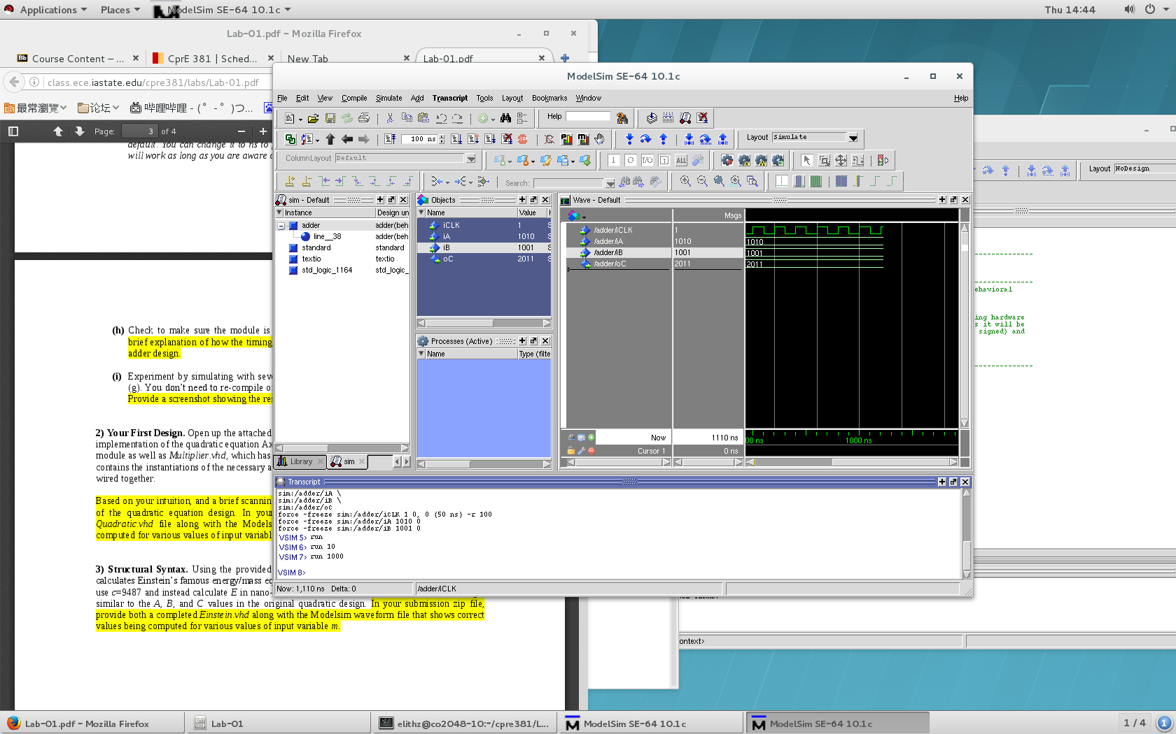

I tried to change the number inside the adder by change the value of variables in ModelSim, and also got some result:

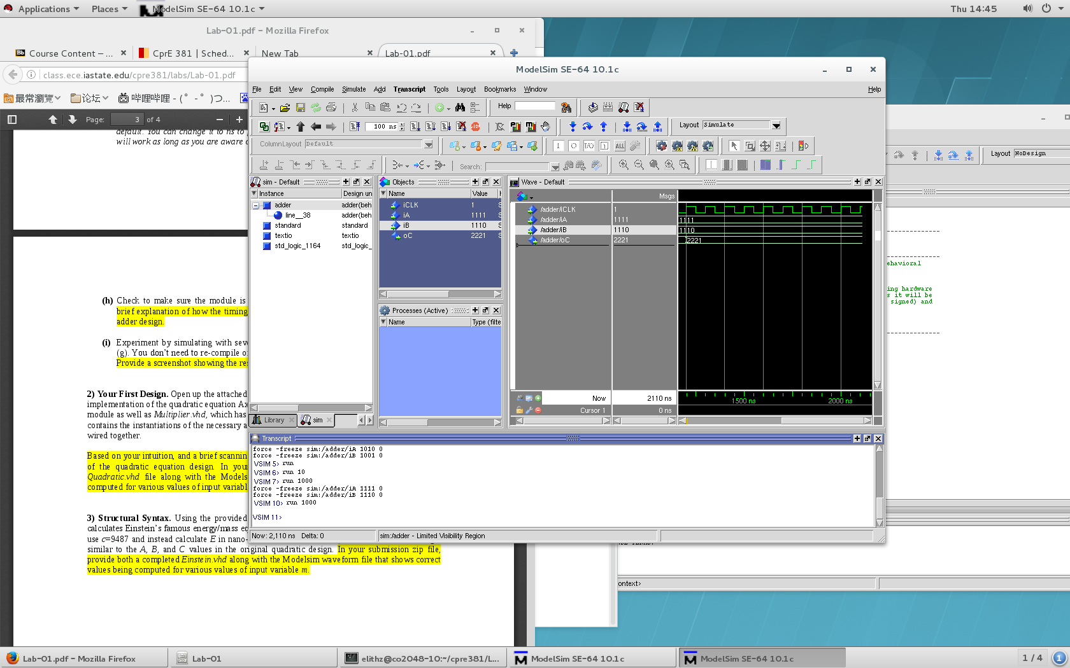

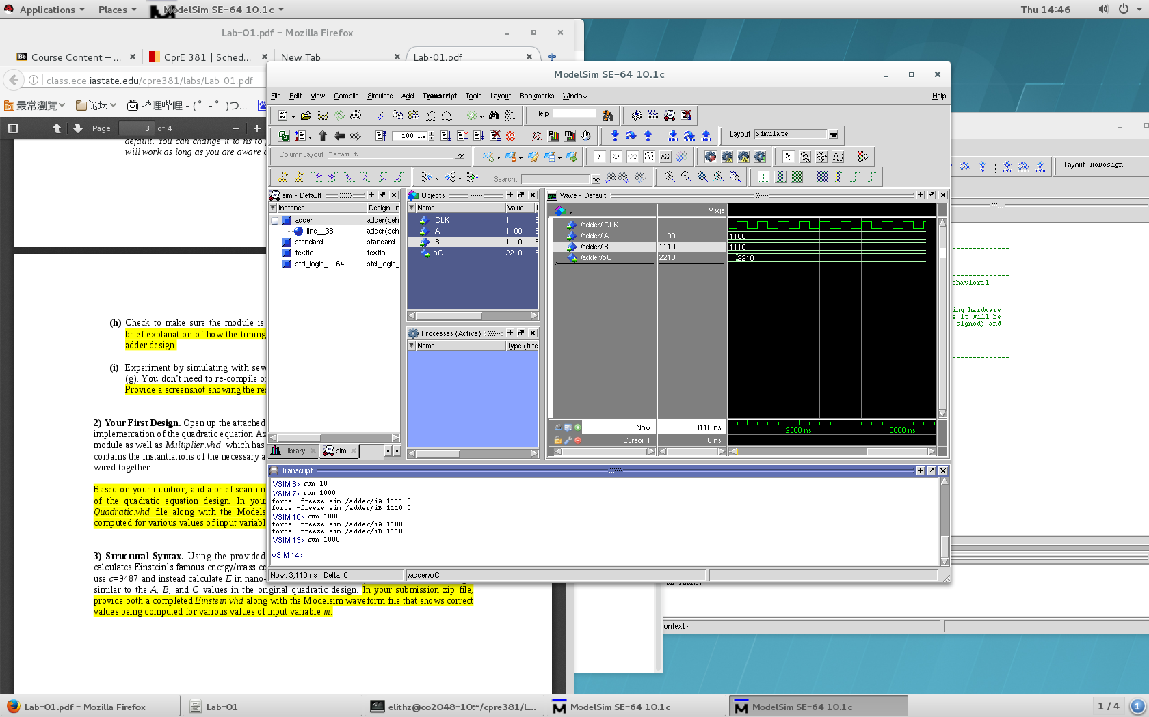

Part 2: Your First Design

In this part, it required us to design a programe which combined the adder and mulpiplier which is another programe block the project already prepared for us to meet the result of equation Ax2 + Bx + C. I needed to go to the source code to implement the code to let it achieve its goal. I tried to read the part that was already implemented for us and wrote new code below to complete it. and once I complete the code I used the same way in part one to simulate it and let it run. The screen shoot is shown below:

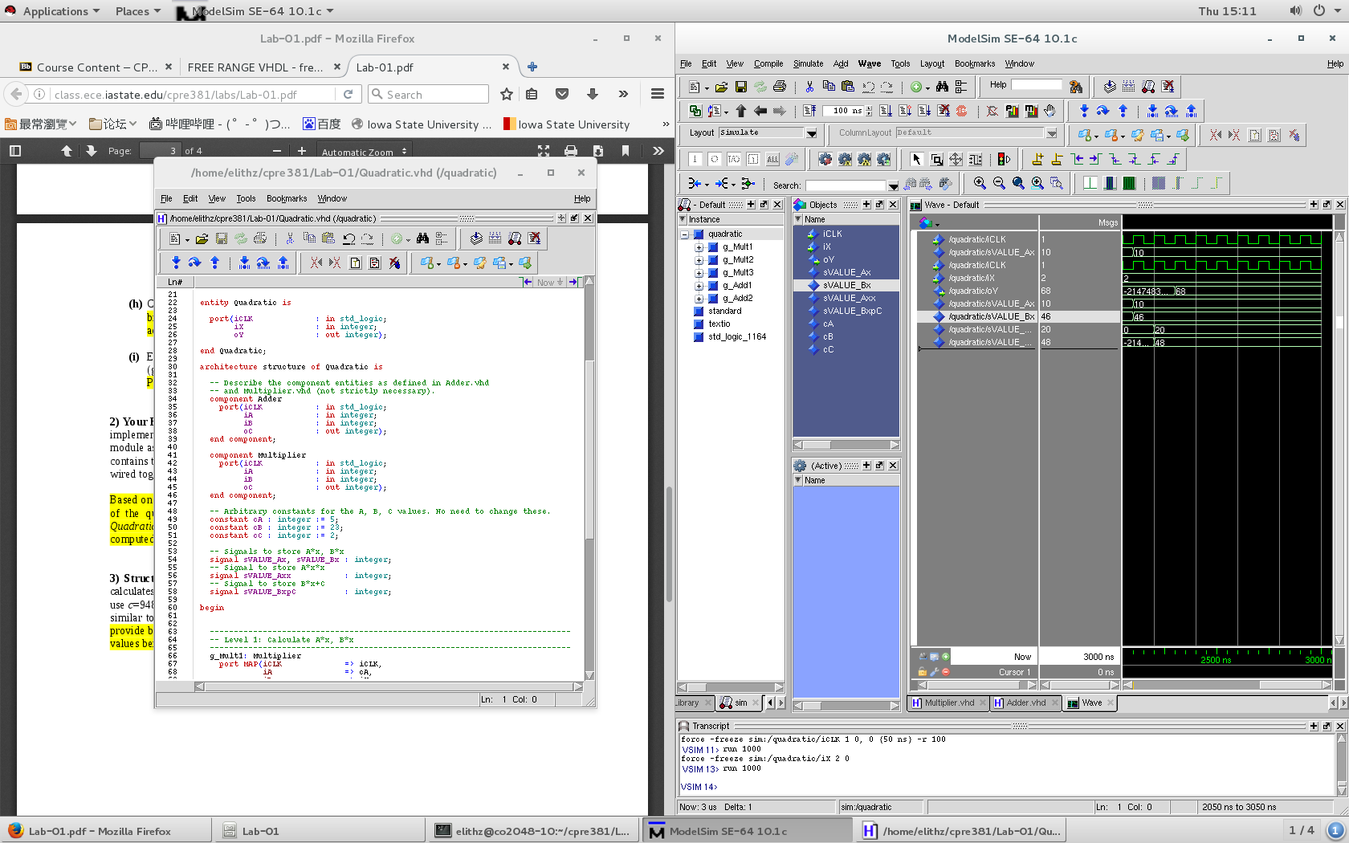

Part 3: Structure Syntax

In this part, we need to modify the programe that we had already done in part 2 to meet a new equation which is E = mc2. C is a constant 9487. After I modified the code, I used the same way to simulate it and run it. The result screen shoot is shown below:

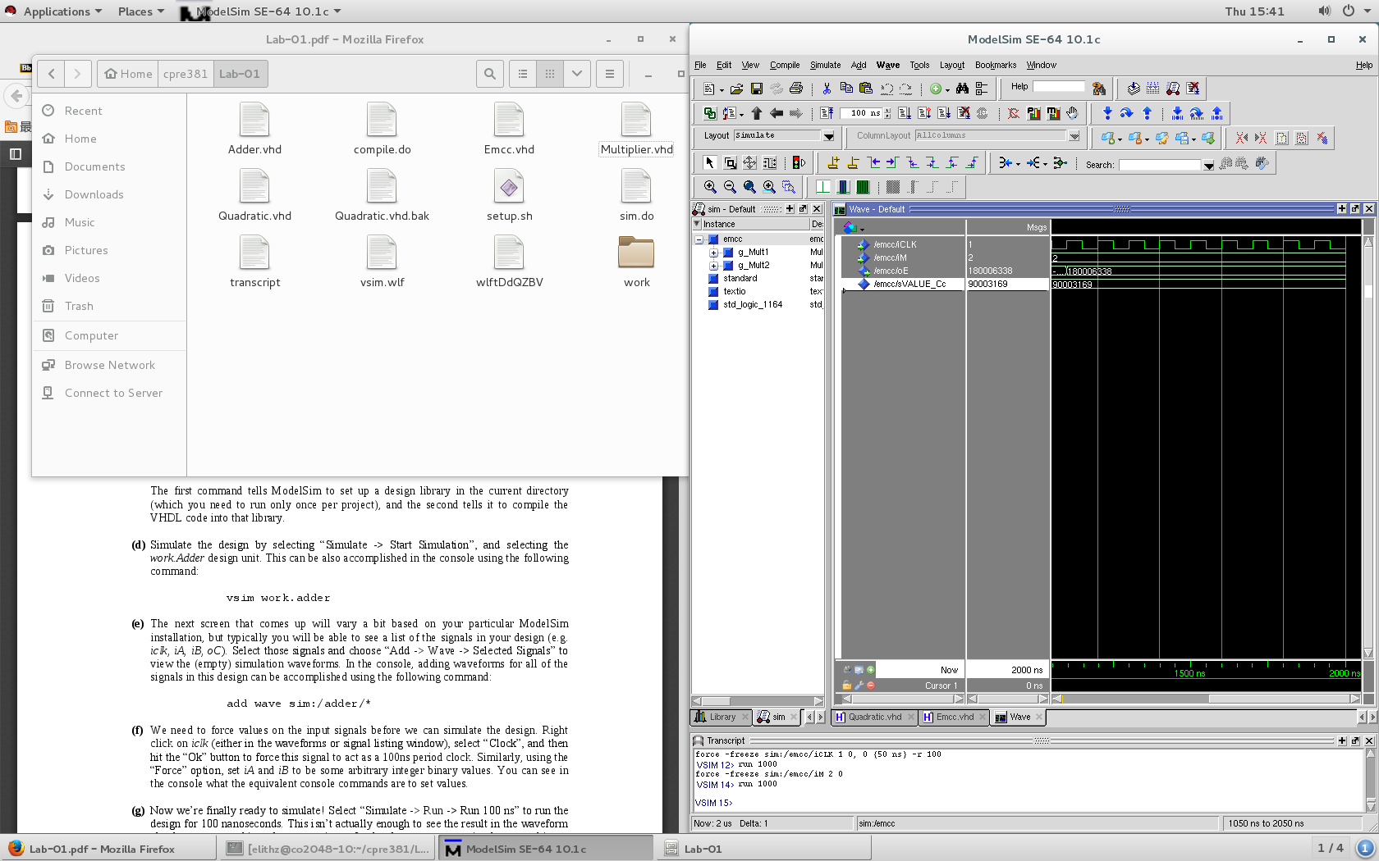

All parts were completed, and their source code and files will be included in the zip pack which I will submit with this report.